Lab 6 Notes

Ehsan Karimi

Following are the screenshots of /etc/sysconf/iptables for all the machines:

Machine A:

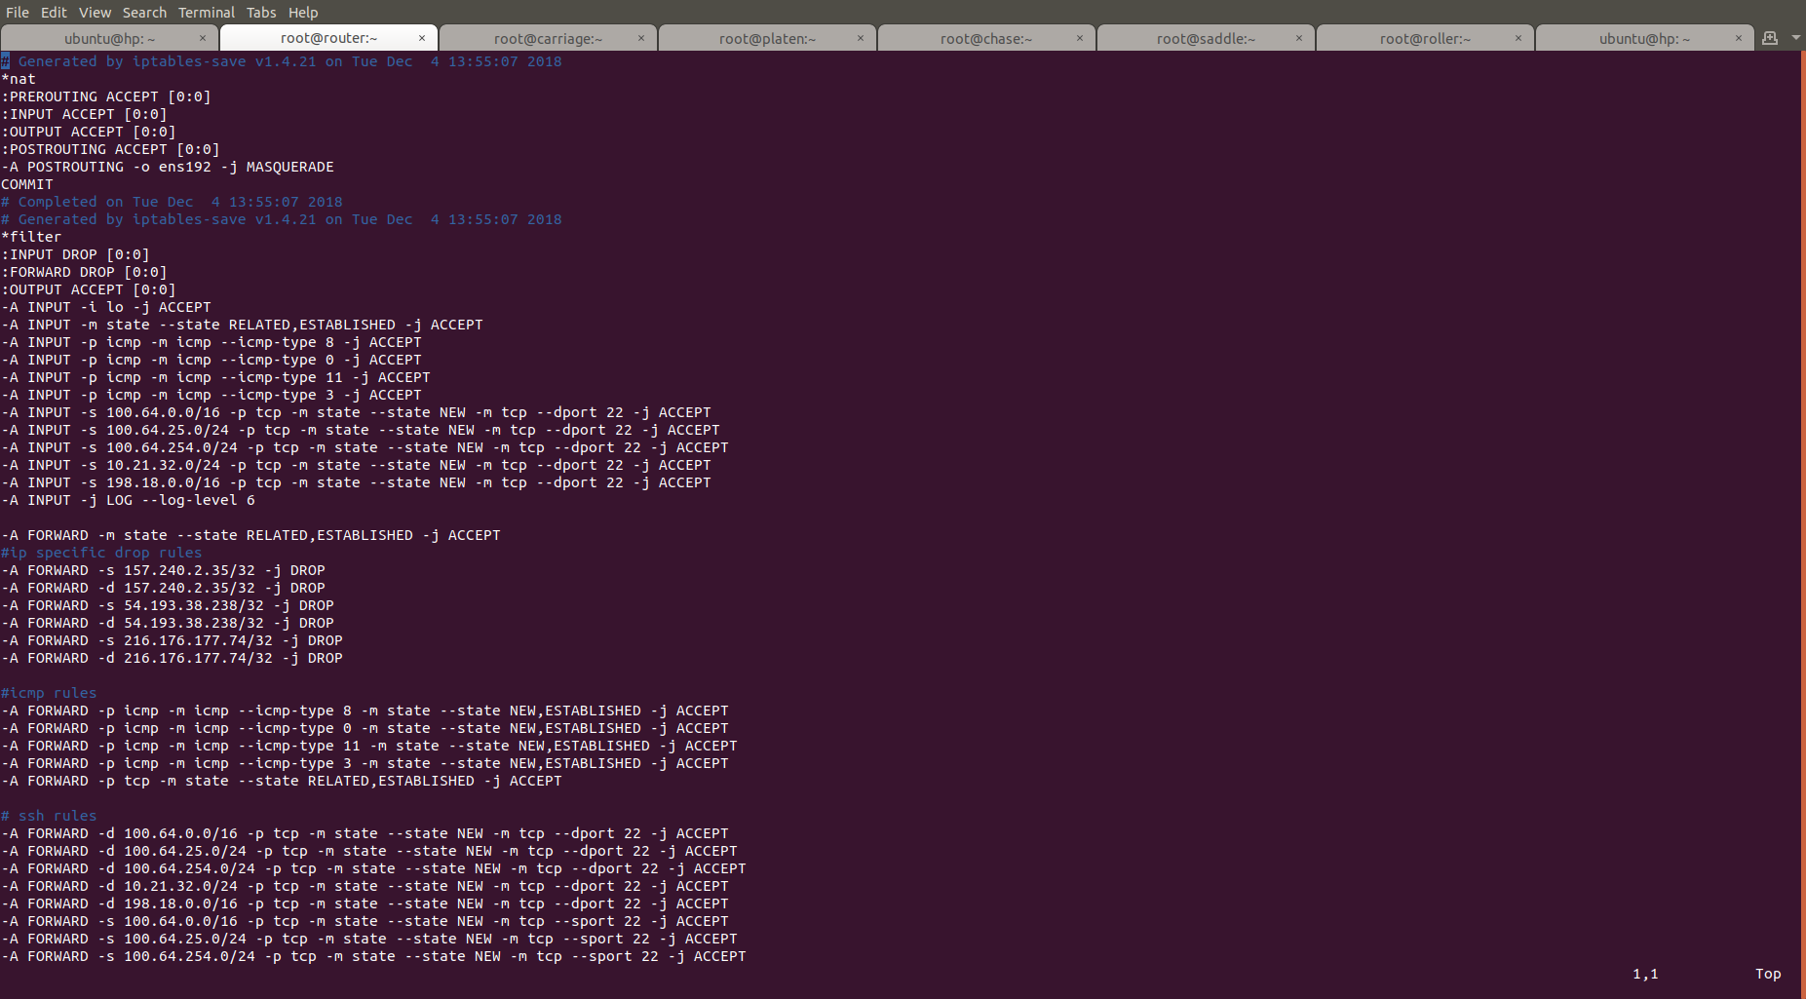

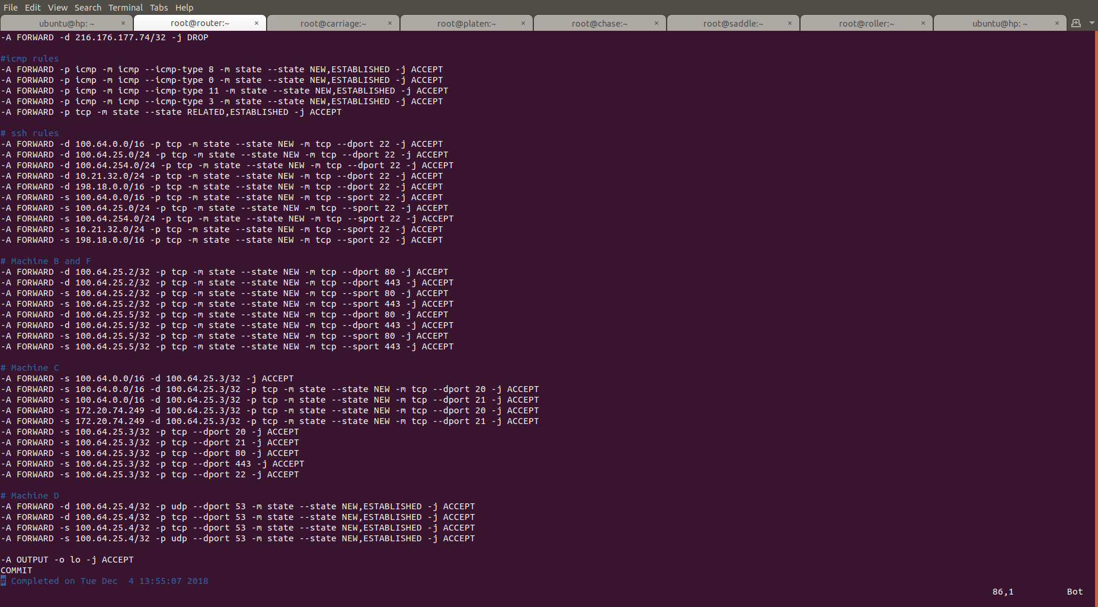

Machine B:

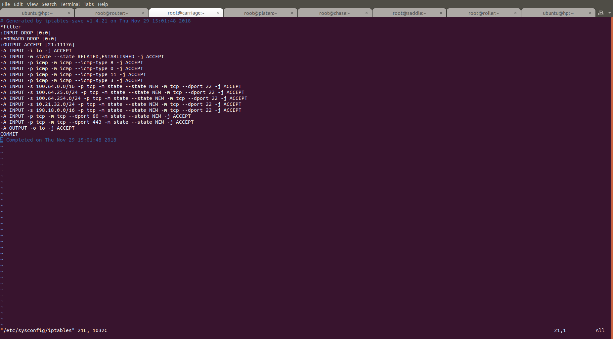

Machine C:

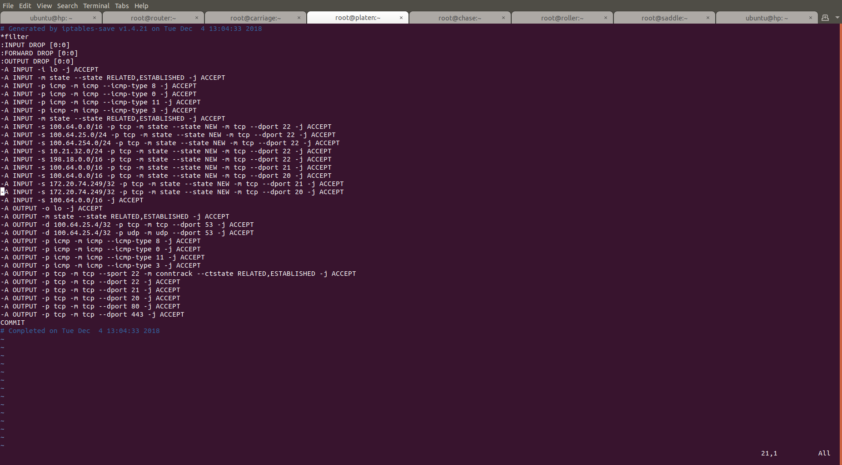

Machine D:

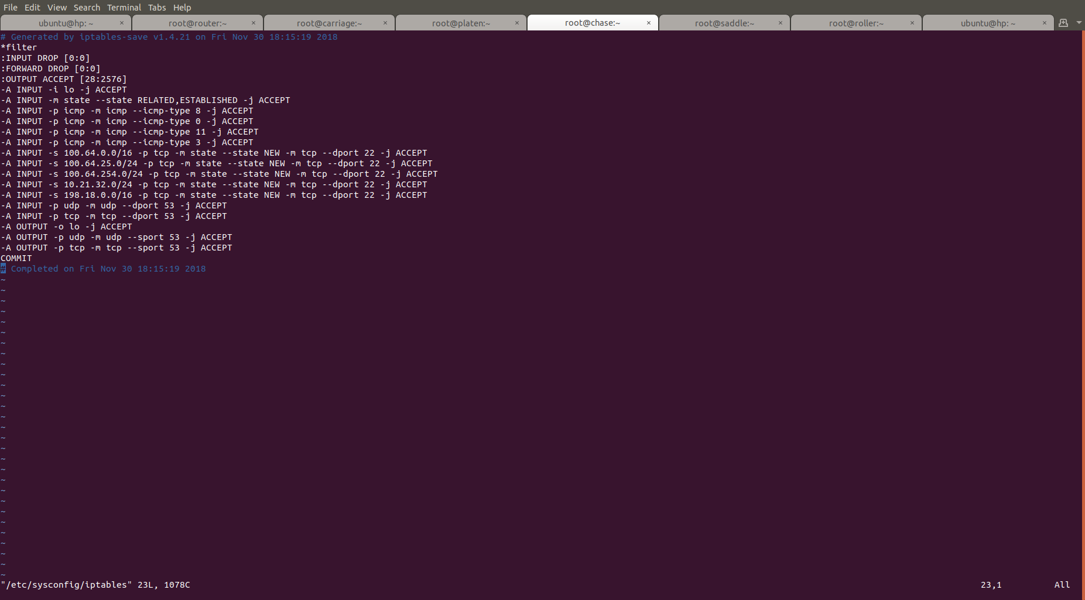

Machine E:

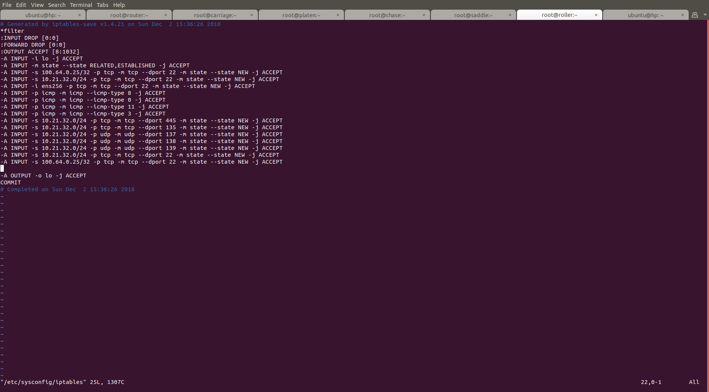

Machine F:

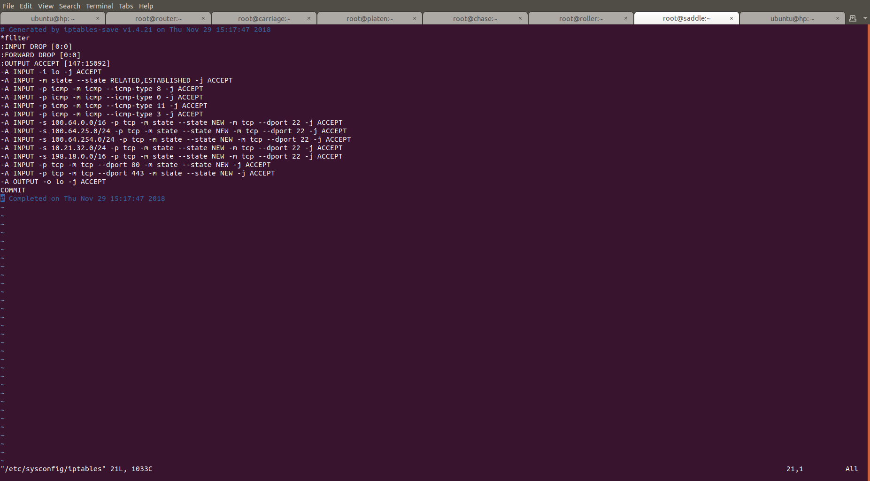

Following are screenshots demonstrating samples of the key functioning requirements:

Blocking Facebook :

allow Inbound Ssh connections:

Sending Http request from external network to machine B:

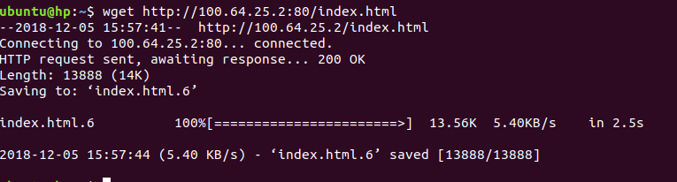
router:

MachineB:

Allow NEW inbound ftp traffic only from 100.64.0.0/16 and 172.20.74.249:

MachineB:
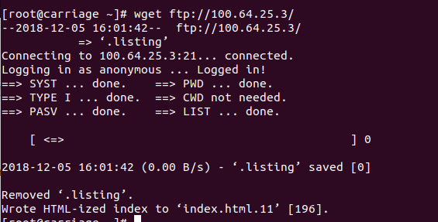
MachineC:

DNS query from machine E:

MachineE:
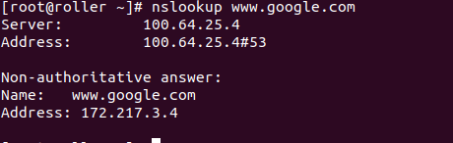

MachineA:

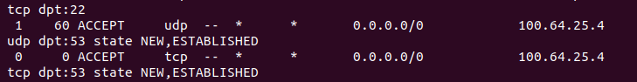
MachineD:

